# Summary of Proteomics of *M. formicicum* with and without activated carbon

## Brief resume of the experiment:

*Methanobacterium formicicum* was incubated in batch assays with and without activated carbon (0.5 g/L) in triplicate assays (working volume of 500 mL). Cells were collected in 3 sampling points in which all the content of the culture was used for protein extraction. This was the strategy used to collect as much cells as possible to obtain the necessary amount of protein for further analysis. In addition, one assay was performed in parallel to follow methane production (Figure 1). The 3 sampling points correspond to: the initial phase of methane production, the middle of the exponential phase and the end of the exponential phase.

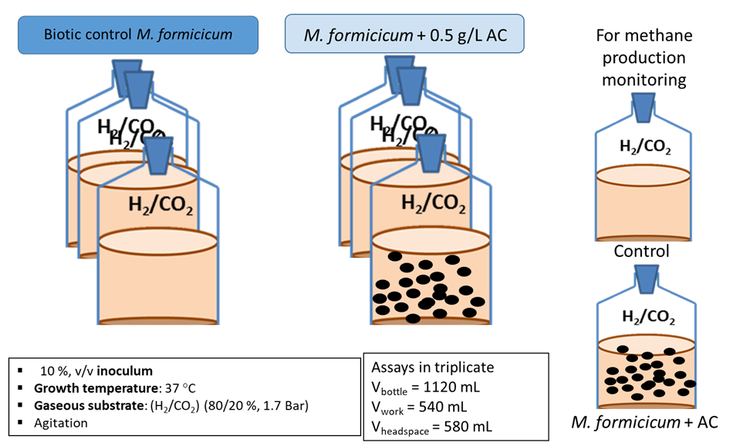

**Figure 1.** Experimental set-up.

## Methane production results:

Methane production by *M. formicicum* cultures was much faster in the presence of activated carbon (Figure 2). The lag phase preceding methane production in the control cultures took more than one week, while in the presence of activated carbon (AC) methane production began after one day of incubation.

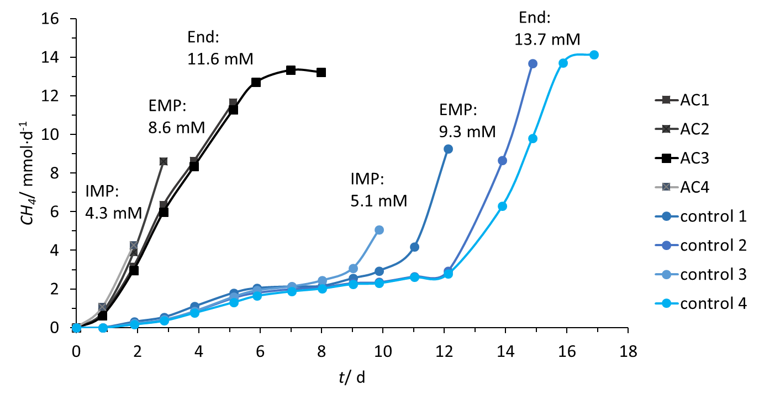

**Figure 2.** Methane production in incubations without AC and with 0.5 g/L AC. The represented curves stopped in the moment of sampling (as the bottles were sacrificed for protein extraction). Here, “IMP” represents the initial methane production, “EMP” means exponential methane production and “End” is the end of methane production.

## Protein extraction, purification and quantification

### Stock solutions

**UTCHAPS buffer**

UTCHAPS buffer consists in a mixture of (7 M) urea, (2 M) thiourea, (4 % w/v) CHAPS, (10 mM) Tris and (1 mM) EDTA in ultra-pure water. The reagents were dissolved at 28 °C under agitation and the process took several hours (around 3 h). The buffer was split in aliquots and stored at -20 °C.

**Dithiothreitol (DTT) solution**

DTT (1 M) was dissolved in ultra-pure water and stored at -20 °C.

**Phenylmethanesulfonyl fluoride (PMSF) solution**

PMSF (0.1 M) was dissolved in methanol, protected from light, and stored at -20 °C.

**Trichloroacetic acid (TCA) solution**

To prepare 100 % stock solution, 5 g of TCA was dissolved in 2.27 mL of ultra-pure water. The concentration in use during protein extraction was 10 %. The solution was stored at -20 °C.

**UTCHAPS buffer – without Tris and EDTA**

UTCHAPS buffer without Tris and EDTA consists in a mixture of (7 M) urea, (2 M) thiourea and (4 % w/v) CHAPS in ultra-pure water. The reagents were dissolved at 28 °C under agitation. The buffer was split in aliquots and stored at -20 °C.

### Sampling

Pure cultures of *M. formicicum* were incubated in (1 L) bottles with 500 mL of volume work. Samples were taken in three different times, namely during the initial methane production (IMP) phase, the middle of the exponential methane production (EMP) phase and in the end of the exponential phase for each condition (with and without AC, respectively). This way, the experiment was conducted with a total of 6 bottles: 3 bottles with the pure culture plus 0.5 g∙L-1 AC and the other 3 bottles without AC. Two bottles (one per condition) were added only to follow the complete methane production (MP) profile. At each sampling point, the bottles were sacrificed and the 500 mL of incubation were distributed by falcon tubes (approximately 40 mL/falcon tube). The collected samples were put quickly on ice and 400 µL of PMSF (at final concentration of 1 mM) were added to each falcon tube in order to inhibit the digestion of proteins of interest by proteases activity. Samples were centrifuged at 10 000 g at 4 °C for 8 min. Pellets were ressuspended with phosphate buffered saline (PBS) with (1 mM) PMSF, and then the samples were stored in eppendorfs LoBind (1 mL of sample per eppendorf and 2 eppendorfs were stored per sampling point in each condition) and frozen at -80 °C until protein extraction.

### Protein extraction and purification procedures

In order to optimize the efficiency of extraction in the samples with AC, the protocol was being modified.

**Part 1: extraction**

Firstly, samples were defrosted. Then, eppendorfs LoBind containing the samples were centrifuged at 8 000 g, at room temperature, for 10 min. Supernatant was removed and 10 µL of PMSF (1mM) was added to the pellet (PMSF first addition – it has to be added each 30 min because it degrades during this time in water). Then, it was added 900 µL UTCHAPS buffer and samples were vortexed for 30 s and put on ice every 5 min for 20 min. After 30 min of the beginning of the procedure, it was added 50 µL DTT (1 M) and samples were vortexed for 30 s and put on ice every 5 min for 10 min. Then, 10 µL of PMSF (1mM) was added (second PMSF addition) and samples were vortexed for 30 s and put on ice every 5 min for 30 min. Another addition of PMSF (third addition) to the samples was made and samples were vortexed for 30 s and put on ice every 5 min for more 30 min. In order to proceed with the mechanical cellular lysis, zirconia and silica beads were added to FastPrep tubes; samples were transferred also to these tubes and it was added again 10 µL of PMSF (1mM) (fourth PMSF addition). At FastPrep equipment, samples with zirconia/silica beads were vortexed for 30 s and put 30 s on ice for around 8 cycles at 6 M/s of velocity. Then, the supernatant was transferred to a new and clean Eppendorf LoBind, avoiding the beads. The beads and FastPrep tube were washed with 300 µL of UTCHAPS buffer. The new eppendorfs LoBind with the samples without beads were then centrifuged at 21 000 g, at 10 °C for 45 min. After centrifugation, 750 µL of supernatant was transferred to a clean tube and 750 µL of acetone (at -20 °C) was added (1/2 v/v). After vortex the sample with acetone, it was added 150 µL of TCA (1/10 v/v) and all the content was vortexed. The samples remained at -20 °C, overnight.

**Part 2: purification**

Designação das amostras – pôr tabela talvez

**Amostra 1 (CS1) –** Cultura pura *Methanobacterium formicicum* (controlo **sem** material), na fase inicial da produção de metano (“initial methane production” – IMP)

**Amostra 2 (CS2)** – Cultura pura *M. formicicum* (controlo **sem** material), na fase exponencial da produção de metano (“exponential methane production” – EMP)

**Amostra 3** **(CS3)** – Cultura pura *M. formicicum* (controlo **sem** material), na fase final da produção de metano (“End of methane production” – END)

**Amostra 4 (CS4)** – Cultura pura *M. formicicum* + 0.5 g/L activated carbon (AC), na fase inicial da produção de metano (IMP)

**Amostra** **5 (CS5)** – Cultura pura *M. formicicum* + 0.5 g/L AC, na fase exponencial da produção de metano (EMP)

**Amostra** **6 (CS6)** – Cultura pura *M. formicicum* + 0.5 g/L AC, na fase final da produção de metano (END)

Resultados quantificação

|  |  |  |  |  |  |
| --- | --- | --- | --- | --- | --- |
| **Descrição da amostra** | **Fase de amostragem** | **Concentração**/(ug/ul) | Volume carregado **no gel SDS**)/ul | **proteína por poço (1 fração)**/ug | **Proteína em 2 frações de amostra** / ug |
| *M. formicicum* (control) | Amostra 1) IMP | 0.215 | 16.2 | 3.5 | 7.0 |
| Amostra 2) EMP | 0.709 | 16.2 | 11.5 | 23.0 |
| Amostra 3) End (*) | 0.12 | 16.2 | 1.9 | 3.9 |
| *M. formicicum* + 0.5 g/L AC | Amostra 4) IMP | 0.232 | 16.2 | 3.8 | 7.5 |
| Amostra 5) EMP(*) | 0.109 | 16.2 | 1.8 | 3.5 |
| Amostra 6) End | 0.373 | 16.2 | 6.0 | 12.1 |
|  |

A concentração da amostra foi medida antes de correr no gel SDS, pelo que poderá ter havido perdas durante a manipulação da amostra nos procedimentos seguintes.

(*) As concentrações das amostras 3 e 5 são medições antes da concentração da amostra; não temos o valor após concentração (não foi possível quantificar).

Se juntarmos todas as fases (fase inicial, exponencial e final da produção de metano) por condição:

* 16.9 ug para o **controlo** (juntando 1 fração de cada amostra) ou 33.8 ug juntando 2 frações de cada amostra
* 11.6 ug para o ensaio *M. formicicum* **+ 0.5 g/L AC** (juntando 1 fração de cada amostra) ou 23.1 ug juntando 2 frações de cada amostra

|  |  |  |  |  |  |  |  |  |  |  |  |
| --- | --- | --- | --- | --- | --- | --- | --- | --- | --- | --- | --- |
|  |  | |  |  |  | |  | |  |  |  |
|  | Gel SDS corrido a: | | 17/04/2019 |  |  | |  | |  |  |  |
|  | L 1 2 3 1AC 2AC 3AC L | | | |  | |  | |  |  |  |
|  |  | |  | |  |  |  |
|  |  | | | | | |  |
|  |  | | | | | |  |
|  |  | | | | | |  |
|  |  | | | | | | |
|  |  | | | | | |  |
|  |  | | | | | |  |
|  |  | |  | |  |  |  |
|  |  | |  |  |  | |  | |  |  |  |
|  |  | |  |  |  | |  | |  |  |  |
|  |  | |  |  |  | |  | |  |  |  |
| 1 – *Methanobacterium formicicum* (control), initial of exponential phase | | | | | |
| 2 – *Methanobacterium formicicum* (control), middle of exponential phase | | | | | |
| 3 – *Methanobacterium formicicum* (control), end of exponential phase | | | | | |
| 1AC – *Methanobacterium formicicum* + 0.5 g/L activated carbon (AC), initial of exponential phase | | | | | | | |
| 2AC – *Methanobacterium formicicum* + 0.5 g/L AC, middle of exponential phase | | | | | |
| 3AC – *Methanobacterium formicicum* + 0.5 g/L AC, end of exponential phase | | | | | |
|  | |
| L - ladder | |

## Sample processing in ITQB

(e.g., trypsin digestion) - information missing

## Mass Spectrometry analysis in ITQB:

Equipment: Peptide mapping by nanoLC-MS using Sciex TripleTOF 6600 mass spectrometer

Each sample was loaded twice, first 1 µl for all samples and the second volume was adjusted based on the results of the previous run with the quantity calculated to obtain the best signal.

## Bioinformatics data analysis:

Two spectra files were obtained for each sample (.wiff and .wiffscan).

### Database

The *M. formicicum* strain used in these assays was DSM 1535 and the corresponding proteome was used as database, together with cRAP database for identification of contaminants and trypsin. The proteome of this strain possesses 2392 proteins (https://www.uniprot.org/proteomes/UP000032423), and the full database contained 2509 sequences. Decoy database was built from the cRAP + *M. formicicum* database.

### Peak picking

Raw files (.wiff and .wiff.scan) were converted to Mascot Generic Format (mgf) using MSConvert for performing protein identification with SearchGUI.

### Protein identification

Protein identification was performed with SearchGUI (3.3.16) using custom parameters: precursor ion mass tolerance = 10 ppm; fragment tolerance = 0.02 Da; digestion: Enzyme, Trypsin, Specific; fixed modifications: Carbamidomethylation of cytosine; variable modifications: oxidation of methionine; maximum missed cleavages: 2; search engines: X!Tandem, Myri-match, MS-GF+.

### Report generation

Peptide-Shaker (1.16.41) was used for browsing results and generating reports – TSV tables of protein identification.

### Protein quantification and normalization

Spectra count was performed on the data available at the protein report of Peptide-Shaker. The results of the spectra counts were normalized to allow the comparison between samples.

## Results

Table 1 - General metrics of protein identification. Quantification of spectra detected in Mass-Spectrometry (MS/MS), Peptide-to-Spectrum Matchings (PSMs), different proteins and different Cluster of Orthologous Groups (COGs) in the samples detected in the samples

|  |  |  |  |  |  |  |
| --- | --- | --- | --- | --- | --- | --- |
|  | *M. formicicum* (control assay) | | | *M. formicicum* with 0.5 g/L AC | | |
|  | Initial of MP | Exponential phase | End of exponential phase | Initial of MP | Exponential phase | End of exponential phase |
| # of spectra | 89092 | 92588 | 83746 | 83681 | 59273 | 86619 |
| # of PSMs | 14773 | 11064 | 19279 | 6370 | 11807 | 15061 |
| # of proteins | 418 | 340 | 542 | 219 | 379 | 434 |
| # of COGs | 368 | 301 | 467 | 196 | 335 | 373 |

A fazer: representar a expressão diferencial nas vias metabólica – só da fase inicial – comparar controlo e AC.